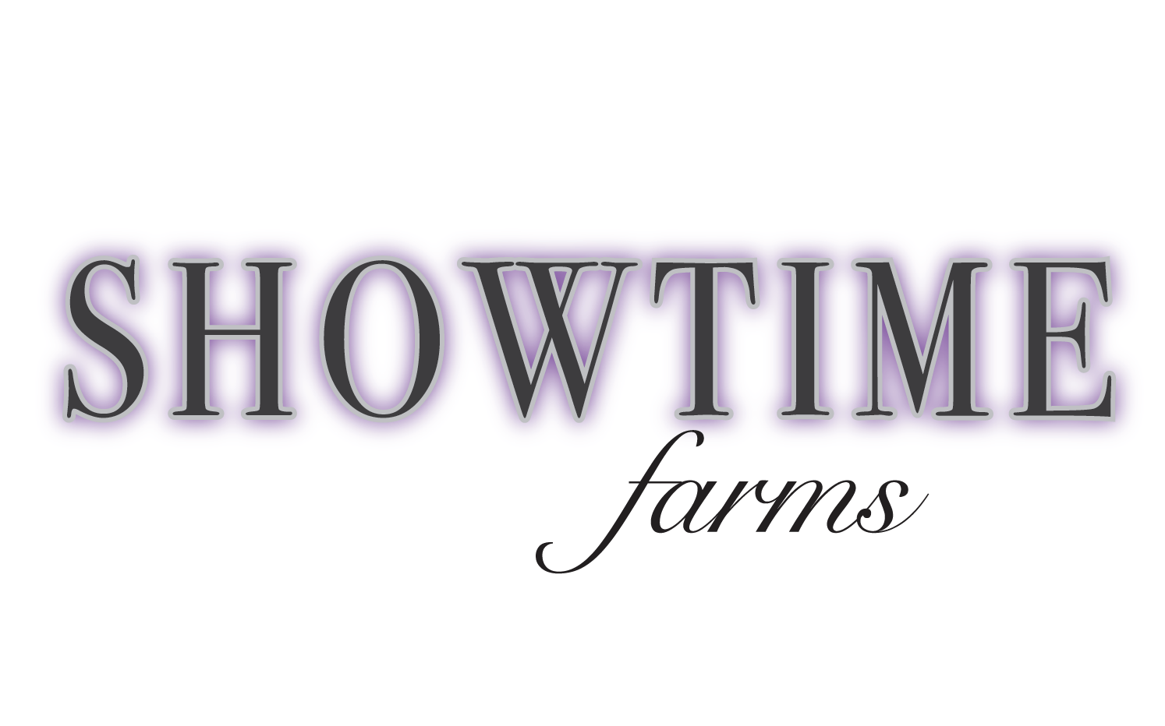
Lesson Packages

If you help get your horse ready!

4 group lessons ($220 value) = $200
4 thirty minute private lessons ($280 value) = $260

8 group lessons ($440 value) = $400
8 thirty minute private lessons ($560 value) = $520

If you rather not get your horse ready!

4 group lessons ($280 value) = $260
4 thirty minute private lessons ($340 value) = $320

8 group lessons ($560 value) = $520
8 thirty minute private lessons ($680 value) = $640

