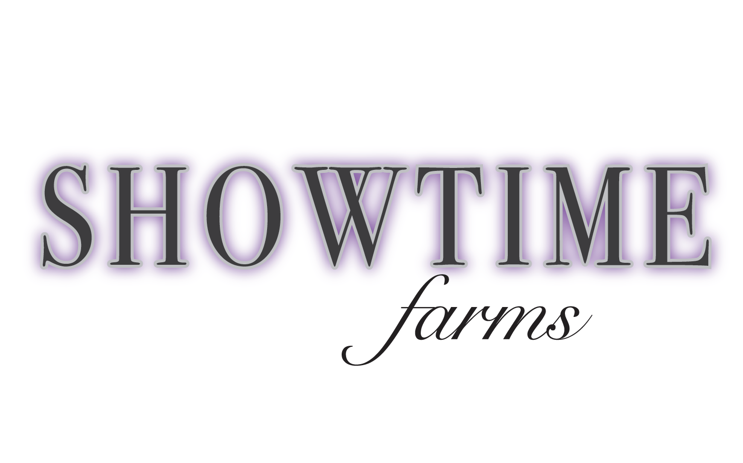
Lesson Packages

If you help get your horse ready!

4 group lessons ($220 value) = $200
4 thirty minute private lessons ($280 value) = $260
4 one hour private lessons ($380 value) = $360

8 group lessons ($440 value) = $400
8 thirty minute private lessons ($560 value) = $520
8 one hour private lessons ($760 value) = $720

If you rather not get your horse ready!

4 group lessons ($280 value) = $260
4 thirty minute private lessons ($340 value) = $320
4 one hour private lessons ($440 value) = $420

8 group lessons ($560 value) = $520
8 thirty minute private lessons ($680 value) = $640
8 one hour private lessons ($880 value) = $840

